Experiment 23: Sharpening of Image using Unsharp Masking
Software / Tools: Python · OpenCV (cv2)

AIM
To sharpen an image using Unsharp Masking, where a blurred version of the image is subtracted from the original to enhance edges.
ALGORITHM
1. Import OpenCV.
2. Read the input image.
3. Create a blurred version of the image using cv2.GaussianBlur().
4. Compute the sharpened image using the formula: sharpened = original + k*(original - blurred), implemented via cv2.addWeighted() with weights (e.g. 1.5 on original, -0.5 on blurred).
5. Display and save the sharpened image.
PROGRAM (SOURCE CODE)
import cv2

img = cv2.imread("image.jpg")

# Step 1: Create a blurred version
blurred = cv2.GaussianBlur(img, (9, 9), 10)

# Step 2: sharpened = original - blurred (weighted)
sharpened = cv2.addWeighted(img, 1.5, blurred, -0.5, 0)

cv2.imshow("Unsharp Masking Result", sharpened)
cv2.waitKey(0)
cv2.destroyAllWindows()

OUTPUT
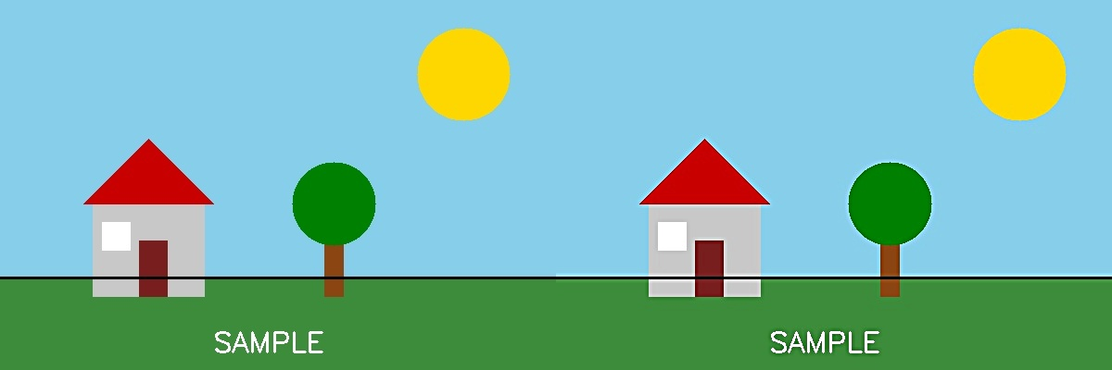
Fig. 23 — Output of Experiment 23: Sharpening of Image using Unsharp Masking.
RESULT
Sharpen an image using Unsharp Masking, where a blurred version of the image is subtracted from the original to enhance edges — completed successfully, as demonstrated in the output shown above.

